Project « reuseit »  - Cédric VONIN

Conception document of the database

(Last update on 2022, November 17th)

Table des matières

Specifications 2

Data dictionnary 3

Le modèle Conceptuel de données (MCD) 6

Le modèle logique de données (modèle relationnel) 10

# Specifications

Check out the specification draft on this folder for more details.

Basic queries to do :

# Data dictionnary

|  |  |  |
| --- | --- | --- |
| **Nom** | **Description** | **Type** |
| Films | Liste des films | Entité |
| * id | Identifiant | AI |
| * titre | Nom du film | Varchar |
| * date_sortie | Date de sortie du film | date |
| * affiche | Chemin de l’image de l’affiche | varchar |
| Individus | Acteurs et réalisateurs du film | Entité |
| * id | Identifiant de l’individu | AI |
| * nom | Nom de l’individu | Varchar |
| * prenom | Prénom de l’individu | varchar |
| Cinema | Liste des cinémas de la chaîne | Entité |
| * id | Identifiant du cinéma | AI |
| * nom | Nom du cinéma | varchar |
| * ville | Ville du cinéma | varchar |
| Participer | Plusieurs individus peuvent participer à plusieurs films avec un rôle spécifique au film | Association |
| Rôle | Rôle de l’individu participant au film | varchar |
| * Individus 1,n * film 1,n |  | Cardinalités |
| Projeter | Plusieurs films peuvent être projetés dans plusieurs cinémas entre deux dates | Association |
| Date début | Date de début de projection du film au cinéma | date |
| Date fin | Date de fin de projection du film au cinéma | date |
| * film 1,n * cinema 1,n |  | Cardinalités |

**Gestion rules :**

* Each list of tasks belongs to a single member.
* Each task belongs to a single list.
* Each forum has 1 to n subjects
* Each subject belongs to a single forum
* Each subject is created by only one author
* Each message belongs to a certain subject
* Each message is written by a single member
* Each PM subject is designed by only one member
* Each PM answers refers to a single PM subject
* Each PM answers is written by a single member
* Each receiver information in the list of PM receivers refers to a single PM subject
* Each receiver information in the list of PM receivers tells only a perso whom receives his message
* The id of the received message id in the PMreciever row is a data from the table pmanswers
* Every id of a subject that a member stopped following is an id from the table PM subjects
* A member that not receives a certain subject whose id is [id] is identified by his id number
* Each blacklist tells who blacklists someone by indicating what is his id.
* Each blacklist is a member who blacklists another, indicated by the id of the blacklisted member.

# Conceptual Data Model (CDM)

<CDM>

<entities>

• members

- id (AI)

- username (varchar)

- password(varchar)

- photo (varchar)

- arrival_date (date)

- description (text)

- status (int)

• lists

- id AI)

- name (varchar)

- description (text)

- visibility (int)

• tasks

- id (AI)

- name (varchar)

- description (text)

- importance (int)

- due_date (date)

- remind_date (date)

- status (int)

• forums

- id (AI)

- name (varchar)

- description (text)

- date (date)

- status (int)

• subjects

- id (AI)

- name (varchar)

- pinned (int)

- status (int)

- date (date)

• messages

- Id (AI)

- date (date)

- content (text)

- status (int)

- ip (varchar)

</ entities>

<associations>

make :

- member 1,n

- list 1,1

references :

- tasks 1,1

- lists 0,n

treat :

- tasks 0,1

- subjects 0,1

List :

- forum 1,n

- subjects 1,1

references :

- message 1,1

- subjects 1,n

Send

- Member 1,n

- PrivateMessage 1,n

Recieve (ip_reciever, date)

- Member 1,n

- Private messgage 1,n

Not recieve (date)

- Member 1,n

- Private messgage 1,n

Blacklists

- Member 1,n

- Member 1,n

</associations>

</CDM>

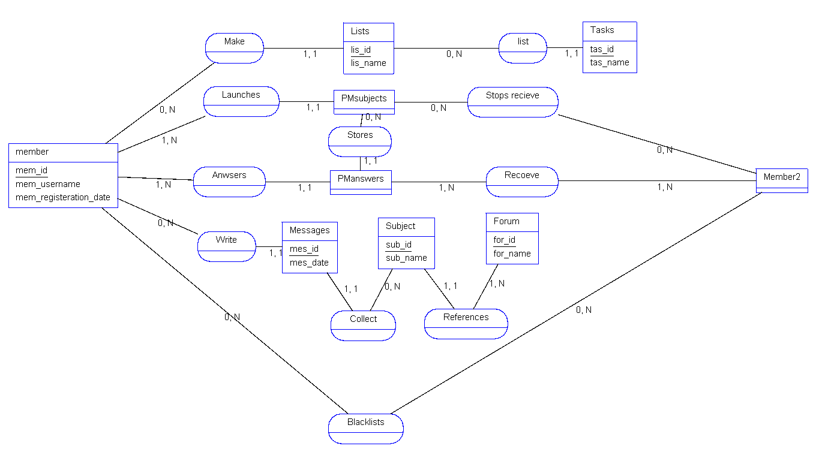

*Graphic CDM*

# Logical data model (LDM)

<LDM>

<tables>

• members

- id (AI)

- username (varchar)

- password(varchar)

- photo (varchar)

- arrival_date (date)

- description (text)

- status (int)

• lists

- id AI)

- name (varchar)

- description (text)

- visibility (int)

• tasks

- id (AI)

- id_list (FK)

- name (varchar)

- description (text)

- importance (int)

- due_date (date)

- remind_date (date)

- status (int)

• forums

- id (AI)

- name (varchar)

- description (text)

- date (date)

- status (int)

• subjects

- id (AI)

- id_forum (FK)

- task (FK or NULL)

- name (varchar)

- pinned (int)

- status (int)

- date (datetime)

• messages

- Id (AI)

- id_member (FK)

- id_subject (FK)

- content (text)

- status (int)

- date (datetime)

- ip (varchar)

• pmsubjects

- id (AI)

- id_author (FK)

- id_task (FK NULL)

- status (int)

- name (varchar)

- ip (varchar)

• pmanswers

- id (AI)

- id_pmsubject (FK)

- id_sender (FK)

- message (varchar)

- date (dateitme)

• pmrecievers

- id (AI)

- id_pmsubject (FK)

- id_answers (FK)

- id_reciever (FK)

• pmnotrecieve

- id (AI)

- id_pmsubject (FK)

- id_member (FK)

- date_stop (datetime)

• pmnotrecieve

- id (AI)

- id_member (int)

- id_blacklisted (int)

</tables>

</LDM>

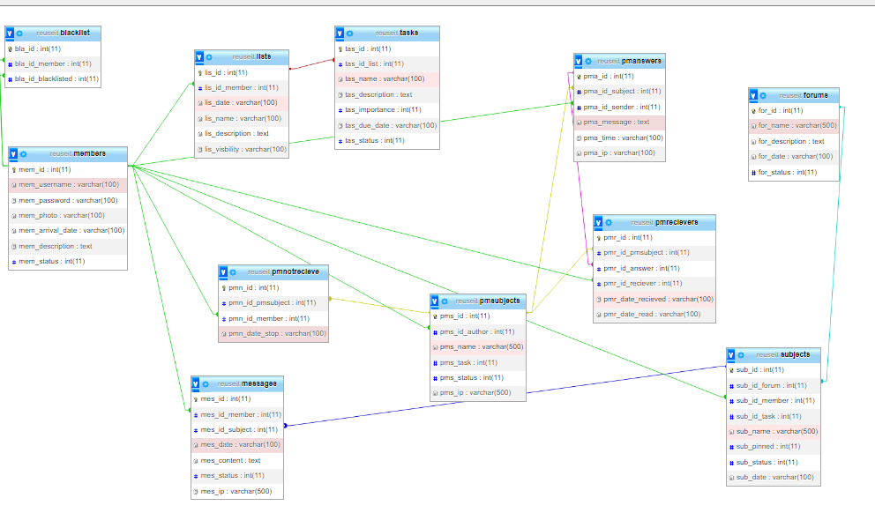

*Graphic of Logical data model*

SQL script: check out “reuseit.sql”